What You Really Should Know About
The Enbridge Sandpiper Pipeline Project

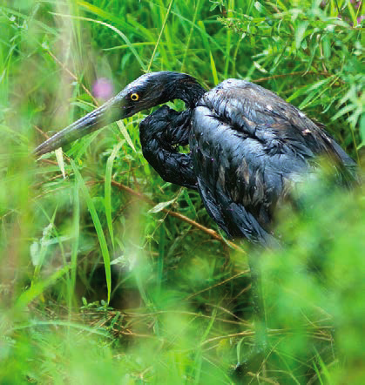
Great Blue Heron on the Kalamazoo
River, covered in tar sands oil from
the 010 Enbridge pipeline spill

- Your land value will decrease.
- Compensation will not cover the value of your loss.
- The Sandpiper Pipeline will carry oil extracted from the Bakken oil shale formation in North Dakota.
- Oil shale development wastes as much as 5 barrels of water for every barrel of oil produced.
- Oil shale produces 15-50% more Greenhouse Gases than conventional oil because it is heated to 1000°F for 2-3 years before it can be extracted.
- The Bakken Shale formation contains high levels of corrosive hydrogen sulfide.
- Hydraulic “fracking” is used to extract crude oil from oil shale.
- Tar sands oil could potentially be carried in the Sandpiper Pipeline.
- Tar sands oil is one of the world’s dirtiest, costliest, and most destructive fossil fuels.
- An Enbridge pipeline ruptured in 2010 and released over 1 million gallons of tar sands into Michigan’s Kalamazoo River system harming people and wildlife.
- Cleanup continues to this day.
- Nearly 1.5 million gallons of oil have spilled from Enbridge pipelines into northern Minnesota wetlands and waterways.
- The Sandpiper Pipeline crosses the Red, Mississippi, St. Louis, and Nemadji River watersheds.
- The St. Louis and Nemadji Rivers feed Lake Superior – a National Estuarine Research Reserve.

For further information contact Carlton County Land Stewards at www.carltoncountylandstewards.org or 1-888-382-7940 of Spills Quantity

